

**NAME:** KASHIF MAJID DAR

**DIVISION:** CS B1

**PRN:** 19070122084

***ASSIGNMENT 7***

***AIM***: Write a program to perform various operations such as union and intersection on the given sets.

***THEORY:***

A [Set](http://mathworld.wolfram.com/Set.html) is a collection of well-defined and distinct objects.  
[Intersection](http://math.comsci.us/sets/intersection.html) of two sets A and B is defined as, all the elements of set A, which are also elements of set B. [Union](http://www.basic-mathematics.com/union-of-sets.html)of two sets A and B is defined as, all the elements of A and B, but not belonged to both.

***ALGORITHM:***

STEP 1: START

STEP 2: ENTER VALUES FOR ARRAY 1

STEP 3: ENTER VALUES FOR ARRAY 2

STEP 4: CHECK IS ELEMENTS OF ARRAY 1 AND ARRAY 2 IS SAME

STEP 5: PRINT COMMON ELEMENTS FOR INTERSECTION

STEP 6: COMBINE BOTH THE ARRAYS

STEP 7: PRINT THE OBTAINED ARRAY FOR UNION

STEP 8: STOP

***FLOWCHART:***

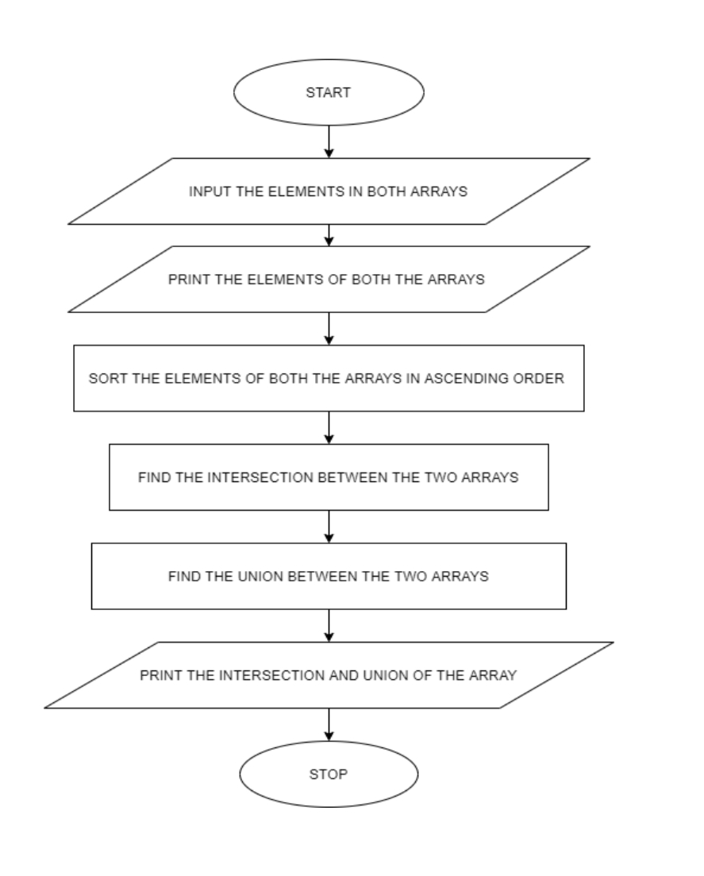

***SOURCE CODE:***

#include<stdio.h>

main()

{

int a[150],i,n,b[150],j,m,c[150],d,k=0;

printf("Enter size of array: ");

scanf("%d",&n);

printf("Enter %d elements in the array : ", n);

for(i=0;i<n;i++)

{

scanf("%d", &a[i]);

}

printf("\nElements in array are:{ ");

for(i=0;i<n;i++)

{

printf("%d ", a[i]);

}

printf("}");

printf("\nEnter size of array: ");

scanf("%d",&m);

printf("Enter %d elements in the array : ", m);

for(j=0;j<m;j++)

{

scanf("%d", &b[j]);

}

printf("\nElements in array are:{ ");

for(j=0;j<m;j++)

{

printf("%d ", b[j]);

}

printf("}");

//intersection

printf("\nintersection is : { ");

for(i=0;i<n;i++)

{

for(j=0;j<m;j++)

{

if( a[i]==b[j])

printf("%d ", a[i]);

}

}

printf("}");

//union

printf("\nUnion is : { ");

for(i = 0;i<n;i++)

{

c[k] = a[i];

k++;

}

for(j=0;j<m;j++)

{

for(i=0;i<n;i++)

{

if (b[j] == a[i])

{

d++;

break;

}

else

d = 0;

}

if (d == 0)

{

c[k] = b[j];

k++;

}

}

for (j = 0; j<k ; j++)

{

printf("%d ",c[j]);

}

printf("}");

}

***OUTPUT*:**

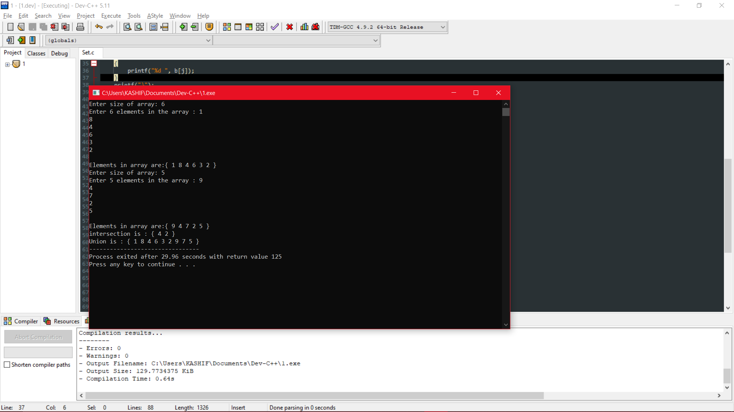

***CONCLUSION*:**

I LEARNED ABOUT USE OF ARRAYS AND LOOP IN THIS EXPERIMENT